Project Initialization And Planning Phase

|  |  |
| --- | --- |
| Date | 06 JULY 2024 |
| Team ID | 739909 |
| Project Name | Unlocking Silent Signals: Decoding Body Language With Mediapipe |
| Maximum Marks | 3 Marks |

**Define Problem Statements (Business Problem Specification Template):**

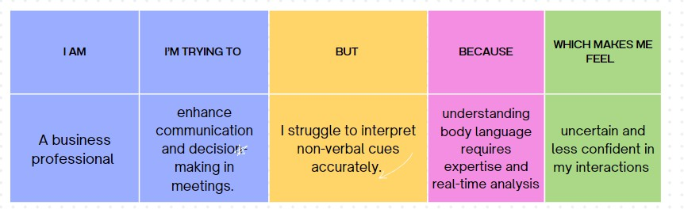Businesses and individuals often struggle to interpret non-verbal cues, leading to miscommunication and missed opportunities. Our goal is to develop a system using Mediapipe that accurately decodes body language in real-time. This system will enhance communication, decision-making, and engagement by providing immediate feedback on silent signals. Target users include businesses, healthcare professionals, educators, and individuals seeking to improve personal interactions. The expected outcome is improved understanding and interpretation of non-verbalcues, resulting in more effective and meaningful communication.

|  |  |  |  |  |  |
| --- | --- | --- | --- | --- | --- |
| **Problem Statement**  **(PS)** | **I am** | **I’m trying to** | **But** | **Because** | **Which makes me**  **feel** |
| PS-1 | A business professional | enhance communica tion and decision- making in meetings. | I struggle tointerpret non-verbal cues accurately. | understanding bodylanguage requires expertise and real-time analysis | uncertain and less confident in my interactions |